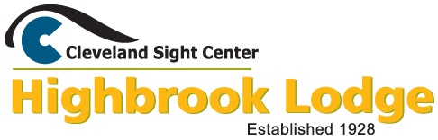

2018

CAMP REPORT

Prepared by Mollie Evans, Therapeutic Recreation Specialist

Camper Outcome Data – Programming
Why gather outcome data from programming?
Therapeutic Recreation (TR) strives to improve overall quality of life through various leisure/recreation activities and interventions. Goals and objectives are set to measure the progression of each client who receives services. As a summer residential camp with a TR focus, Highbrook measures the progression of campers in physical, emotional, cognitive, psychological, and spiritual health goals. Campers engage in various programs throughout the day (Music, Arts, Sports, Outdoor Activities, Nature, and Swimming) with pre-determined goals and objectives that encourage camper independence and improved overall quality of life. Therefore, it is imperative to gather and evaluate data from these various programs to assess the progression of campers and the effectiveness of programs in providing opportunities for campers to meet these goals and objectives.

Process of gathering data
Program leaders set various goals and objectives for each of their programs. They are trained in writing effective goals and objectives that meet the needs of Highbrook’s campers and are attainable in their program areas. During implementation, program leaders observe and document if/when campers have met the goals, based on successful completion of the objectives (which are usually measured quantitatively). Campers must meet at least two stated objectives to have met the goal. All camper data is gathered and included in a chart on the program’s evaluation, which is usually completed the same day and includes further evaluation of the effectiveness/strength of the program with any future considerations for implementation. The data from these evaluations is analyzed by the Program Coordinator, who consolidates the data into individual charts for each camper (via Microsoft Exel). These charts indicate which goals the camper met, in which program, and any additional notes provided by the program leader in his/her evaluation. These charts are then uploaded to CampSite for future use by the Camp Manager and Cleveland Sight Center personnel who may require/benefit from access to this data.

Example Chart

Written by: Sarah Whitehouse, 2018 Program Coordinator and Music Therapy Major

Online Registration System

For the first time ever, Highbrook Lodge used an online registration system to prepare for the upcoming camp season. After extensive research, Camp Manager Linsday Svarovsky decided on using Campsite, an online registration system designed specifically for camps. Campsite also allows administrators to create their own registration forms, which meant that the Camp Leadership Team staff were able to get the most accurate information possible for Highbrook Lodge specifically. All required paperwork had to be filled out in order for a camper to be enrolled, so that no important information could be omitted. This was helpful in collecting information from everything from medical history to ADLs, and allowed seasonal staff to provide the best care possible, with the information given.
Starting in April, Campers were able to register for their preferred session using the forms set up on Campsite. This system allowed campers to register themselves, instead of relying on someone else to fill out paper forms for them. Moving forward, the registration process will be even simpler for returning campers, as the data from the previous summer will already be stored, and will only need verification.
Online registration also made it easier for Leadership Team to track campers through the registration process. Camp staff were able to view when a camper started their application, and where they were at in the application process, which allowed for continuous follow-up on completion or items of note. Once a camper had filled out all of their required paperwork, Leadership Team staff were able to pull reports on different information to be disbursed to Cabin Leaders, Program Leaders, Kitchen Staff, and the Camp Nurse, RN.
Leadership Team staff were able to track payments through the online system, by uploading any payments made through the Eyedea Shop or via check, and then pulling a report to see who still had outstanding payments. Camp staff were also able to generate statements for use in invoicing third parties for camper payments.
Overall, this system was very beneficial in preparation for camp, and allowed for other members of Leadership Team to access information easily when Camp Manager was not able to. This system will also be used as a more comprehensive registration for off-season programming, such as Fall and Winter weekends. We look forward to an even smoother pre-season registration next summer after a year of working with the program ourselves!

Session 1: Adult Celebration
June 25-30, 2018

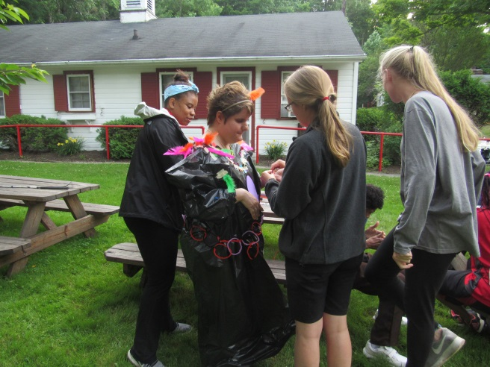

Registered Campers: 23 campers total Utilization: 77%
(14 Male, 9 Female)

Geographical Demographics: 5 – Cincinnati
2 – Cleveland
1 – Akron, Aurora, Berea, Brookpark, Canal Winchester, Cleveland
Hts., Conneaut, Garfield, Garfield Hts., Highland Hts., Lakewood, Madison, Parma, Orrville, Ravenna, Solon
Summary:
Celebration session is for campers with multiple disabilities in addition to their vision loss including hearing loss, physical disabilities, developmental and intellectual disabilities, psycho-social challenges, and chronic medical conditions such as diabetes and epilepsy.

This session provides a wide variety of opportunities for our campers with multiple disabilities to experience the therapeutic benefits of nature and the camp experience. The accessible and goal-based programming of Highbrook Lodge allows for Celebration campers to work on physical, social, emotional, cognitive and individual goals – all working towards increased independence. In addition to traditional camp programming, highlights of this session included: Jungle Bob and his tactile exotic animal show, a group fishing trip and canoeing trip at Geauga Park District’s Headwater Park, a visit from the Great Geauga County Band, a field trip to Hastings Dairy Farm, and overnight campouts in the woods. Finally, the campers were able to exhibit their unique talents in the annual talent show and choir event during the last evening of the session.

Adult Celebration camper, Loretta, says that being at Highbrook has made her want to be more independent.

Session 2: Youth Day Away
July 3, 2018
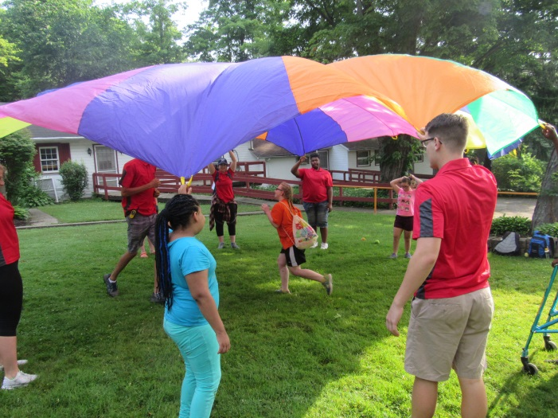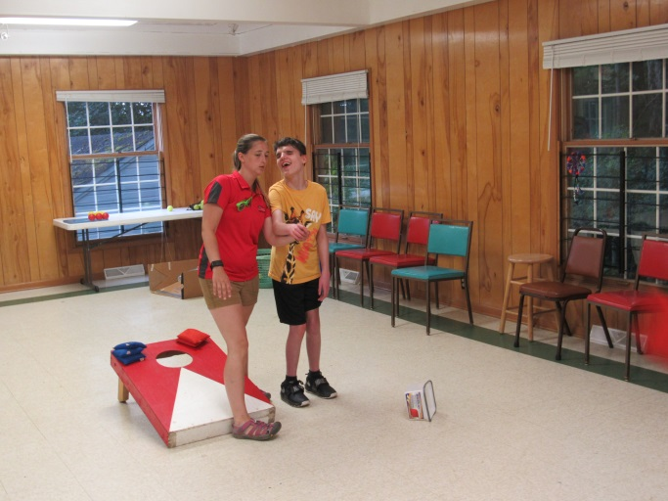
Registered: 10 campers total Utilization: 33%
(3 male, 7 female)
# First Time Campers: 4
Geographical Demographics: 5-Cleveland
1 – Chardon, Chagrin Falls, Cuyahoga Falls, Garfield Hts., Kent

Summary:

Youth Day Away was put on again for the third summer to help introduce and promote the camp experience to potential new campers and also to transition returning campers into their upcoming camp session. Former Chief Executive Officer of the American Camp Association said "[k]ids have to learn how to separate from their families and become resilient and independent. Camp gives them a safe way to take these steps.” About day programs she said, “[k]ids learn about being part of a community and to cope with temporary separation… [t]hey're not only a good transitional step for kids but also for parents…”

Campers were able to experience a full day at camp, arriving at 8:30am and departing after dinner and campfire songs at 6:30pm. Parents were able to meet camp staff, including the Camp Nurse during drop off and pick up. Throughout the day campers participated in traditional camp activities including:
- Cardio Drumming
- Lawn games
- Parachute games
- Making slime
- Hiking
- Swimming
- Campfire songs

Session 3: Adult Resort
July 9-14, 2018
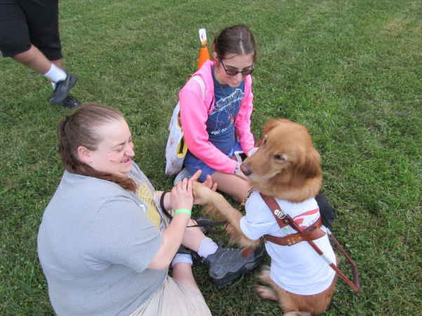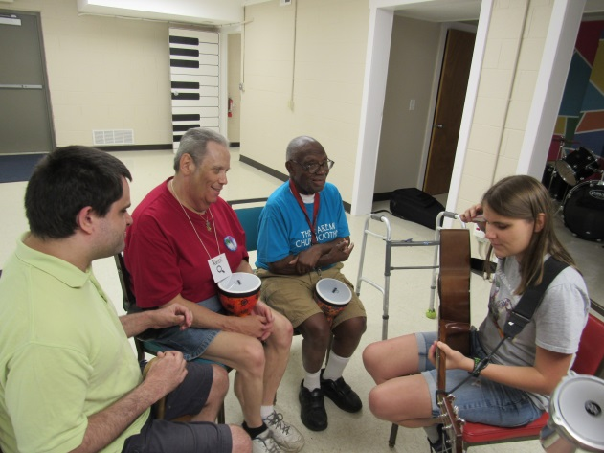
Registered Campers: 29 campers total Utilization: 97%
(12 Male, 17 Female)

# First Time Campers: 4
Geographical Demographics: 5 – Cleveland
4 – Cleveland Hts.
3 – Strongsville
1 – Akron, Canton, Carrollton, Cincinnati, Euclid, Elyria, Greenwich, Hudson, Lorain, New Knoxville, New Philadelphia, Parma, Petersburg (Virginia), Rocky River, Thompson

Summary:
This session is designed to offer a variety of therapeutically-based activities for adult campers with vision loss. The theme for the session was Mystery.

In addition to traditional camp programming such as orienteering and cooking over the campfire, highlights from this session included an optional canoeing trip at Geauga Park District’s Headwater Park, overnight campouts in the woods, and a performance from the Chozen Few Band on the last evening of the session.

Adult Resort camper, Angela, said that she enjoys coming to camp every year because she loves “trying new activities”. Camper was also able to register herself for the first time using the new online system!

Adult Day Trip: this session’s campers were joined by four (4) campers for the day on Friday, July 13th for a trip that gives individuals a chance to be exposed to Highbrook Lodge and experience the benefits of the camp experience. These four campers hail from Berea, Cleveland, Cleveland Heights, North Royalton.

Session 4: Youth Express
July 16-20, 2018

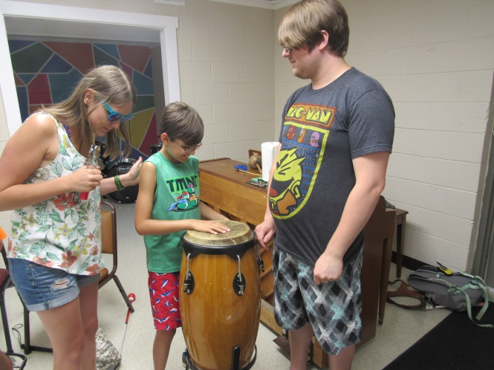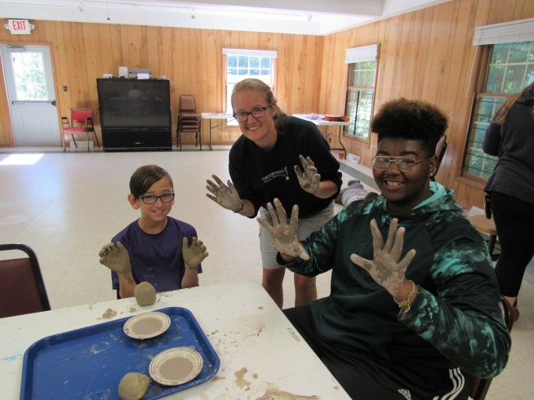
Registered: 10 campers (ages 7-14) 5 male, 5 female
Utilization: 33%

# First Time Campers: 5
Geographical Demographics: 3 – Cleveland
1 – Cuyahoga Falls, Orrville, North Royalton, Barberton, Dover, Killbuck, Columbiana

Summary:
This session provided a shorter, 5-day camp experience for youth ages 7-14. The theme for this session was Myths and Legends. Campers – especially the five new ones – were exposed to programming from Highbrook Lodge’s program areas including arts and crafts, music and drama, nature education, outdoor living, sports and recreation and swimming. Campers were able to participate in activities such as designing masks, bowling, making ice cream, knot tying, hiking, learning how beaches are formed, and more! Each cabin was able to experience an outdoor campout and a visit from Jungle Bob as well. Throughout the session cabins worked on increasing their level of independence through goal-oriented programming. A returning camper was even heard telling his mother “I want to teach you how to make ice cream when we get home!”

First time Youth Express camper Gianna, said that this is the best camp she’d ever been to! She said that the programs were way more fun for her, and she made some great friends!

Session 5: Bright Futures Weekend
July 14-16, 2017

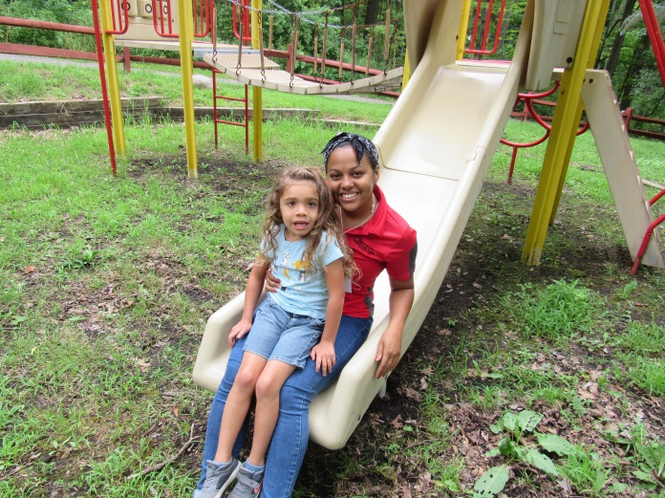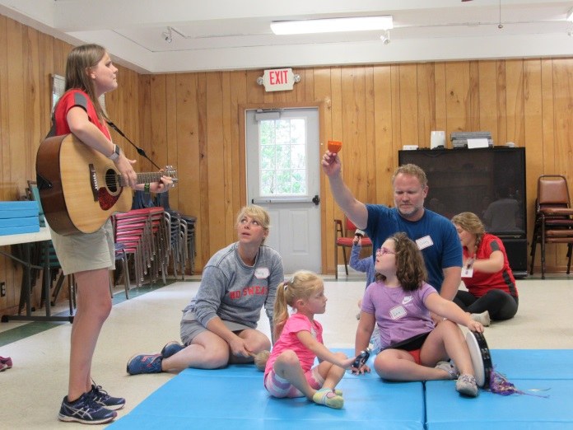
Registered: 5 families total Utilization: 97%
(29 individuals; 8 children with vision loss)
# First Time Families: 1
Geographical Demographics: 2 – Cleveland
1 –Olmsted Falls, Parma, Sylvania

Summary:
In addition to utilizing the benefits of nature and the camp experience to help campers grow, this session is focused on connecting parents of children who have vision loss with someone who may be able to share similar experiences, challenges, and solutions to problems.
The theme for the session this year was a Circus weekend. There were parent specific activities along with children & all-family activities that were planned to allow for an enjoyable, recreation-based weekend for all. Parent-specific programs included a yoga session led by Barbara Williams, Early Intervention Specialist, and a bath salt kit put together by CYAS Case Manager Laurie Schlickman.
In addition, families were treated to a wide variety of circus-themed camp programming including making paper plate animals and working with clay, Big Top Bowling, and an animal exploration. The weekend was capped off with a visit from, swimming, campfire songs, and a family-focused hike throughout the camp property.

First time family, the Harshmans, sent the following words: “Your team of counselors; not really sure if these words do justice to how amazing each one of them is, but their kindness, dedication, skill, loving personalities, compassion, attention to detail...I could go on and on. We were blown away…Needless to say, we’ll be back next year!”

Session 6: Bright Futures Day Trip
July 22, 2018
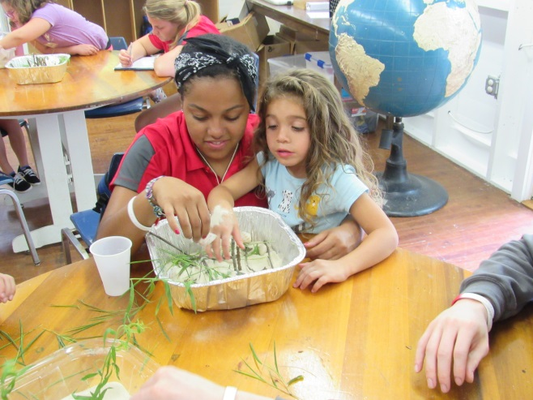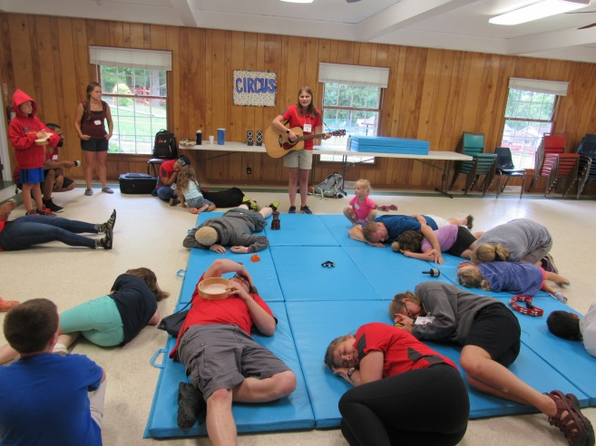

Registered: 2 families total
(10 individuals; 2 children with vision loss)

# First Time Families: 2
Geographical Demographics: 1 – Strongsville
1 – Columbus

Summary:
Due to the increase in demand for the Bright Futures weekend camp in summer 2016 and the interest of families to have a day-option, the Bright Futures Day Trip was added this year. Two families joined the staff and campers from Bright Futures Weekend at Highbrook Lodge to experience the benefits of joining together with other families in the camp experience.

Families enjoyed the experience of what a full day at camp looked like, arriving just after breakfast and joining in activities and lunch with the families attending Bright Futures Weekend. Throughout the day, families participated together in activities from arts and crafts to music to ball games to playing in the sand pit

Session 7: Youth Extended
July 25-August 4, 2018

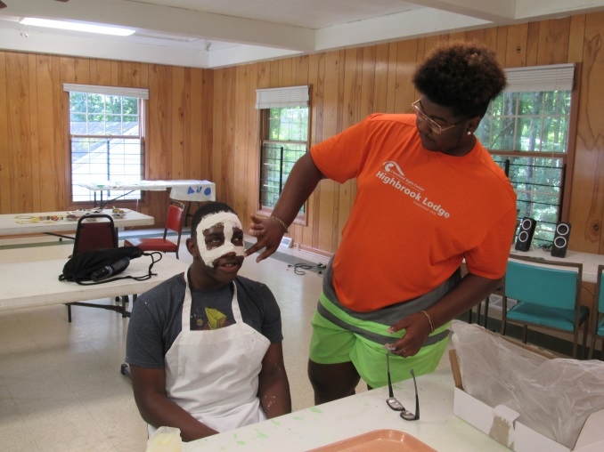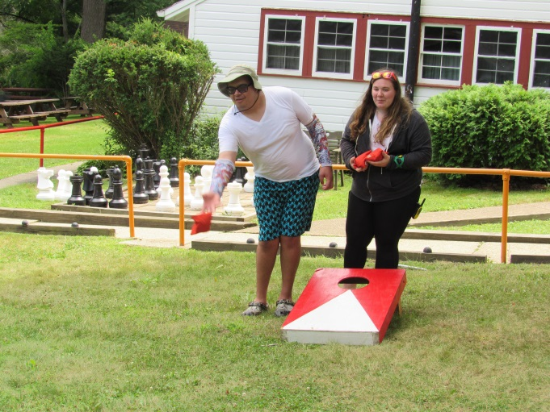
Registered: 10 Tweens (ages 11-14) 4 male, 6 female
9 Teens (ages 15-21) 5 male, 4 female
19 campers total 9 male, 10 female
Utilization: 63%

# First Time Campers: 2
Geographical Demographics: 3- Cleveland
2 – Akron
1 – Barberton, Brimfield, Brunswick, Chagrin Falls, Chardon, Clinton,
Euclid, Garfield Hts., Kent, Mentor, Milan, North Olmsted, Wellington
1 – West Springfield, Pennsylvania

Summary:

The theme of the entire 11 days was based around “Superheroes”, with Highbrook being the training academy for extraordinary young heroes to cultivate their powers. Activities were related to the theme, including evening programs. Among other things, campers made tie dyed capes, plaster masks, and dream catchers in arts and crafts; had a drum circle, wrote their own superhero theme songs, made movie trailers, and learned how to cardio-drum in music and drama; worked on teamwork in sports and recreation activities such as obstacle courses, relay races and a rousing game of Super ball; made ice cream, and learned about constellations and animal super powers in nature; and learned about shelter building, fire building, cooking over the campfire, and orienteering in outdoor living. Every day ended with different evening programs, also focused around the session theme. The session culminated with the “Hero’s Quest” – a team-focused challenge where campers worked together utilizing all they had learned throughout the session. Another important focus for the campers in our Tweens and Teens session was a cabin clean up hour where each member of a cabin group was responsible for cleaning up their bunk area and assisting their peers and staff in maintaining the cleanliness of their cabin. “Power Points” were awarded daily for the cleanest [and most spirited] cabin!

Other magical highlights of the session included the following: overnight campouts in traditional tents; trips to Geauga Park District’s Headwater Park for canoeing; a visit from Jungle Bob’s tactile animal showand fly-in visits from some very special friends (see below).

Returning Tween camper, Alijah, said: “Camp is always fun, I had fun last year, but this was the best summer ever!”

Returning Teen camper, Whitney, said: “Camp has helped me to be more independent and to be able to figure out more things to do that are fun, and I was able to make lots of friends!”

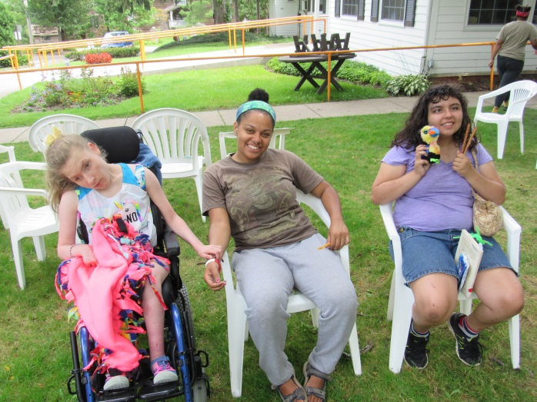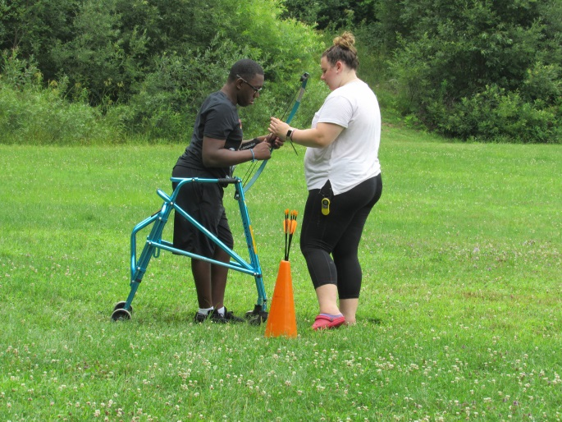
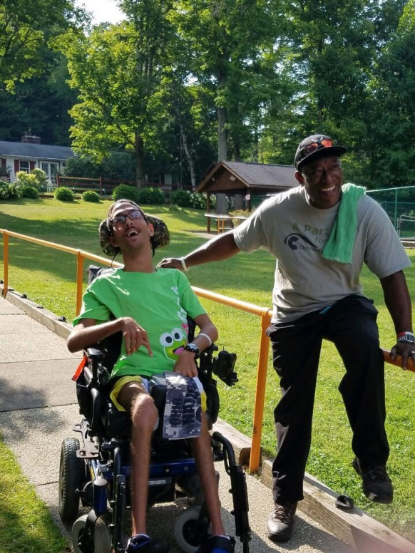

2018 Volunteers

We were once again fortunate to benefit from the volunteerism of several organizations that provided a day of service to clean, paint, rake, and repair and help us keep the camp beautiful and maintained. Time and talent were provided to Highbrook Lodge this year by:
- Cleveland Clinic
- Riverside Group
- Progressive Insurance (Special Lines/IT)
- Delta Gamma Alumni East
- Oswald Financial

We were lucky to be supported by three volunteers who dedicated their time and energy over the summer to assist us in our camp programming. Volunteers included: Ben Fischbach, Nicole Roberge, and Joseph Svarovsky .

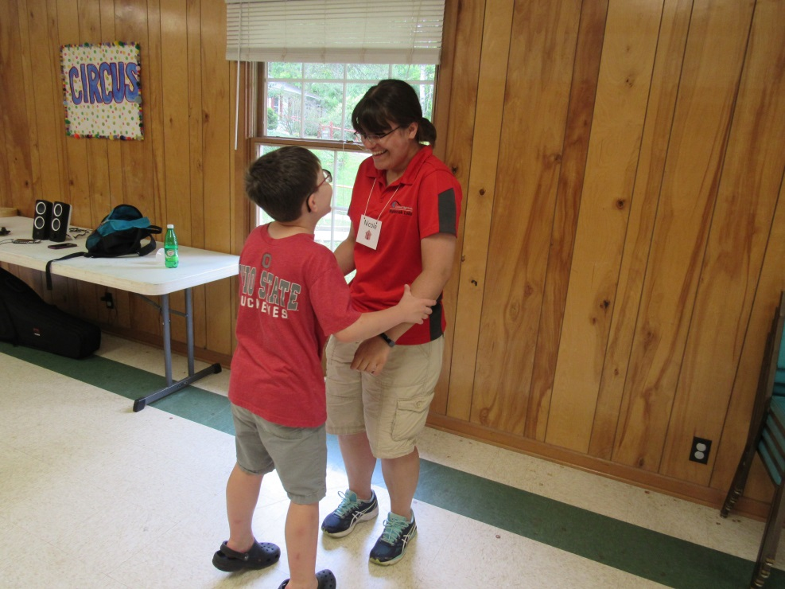

2018 Camper Attendance

Session | 2016 Camper Attendance | 2017 Camper Attendance |  | 2018 Camper Attendance | Session Length (days) | Actual Camper Days Attended
Adult Celebration | 28 | 28 |  | 23 | 6 | 138
Adult Resort | 18 | 28 |  | 29 | 6 | 174
Bright Futures (day + weekend) | 31 | 41 |  | 29 | 1 + 3 | 48
Kids | 7 | ---- |  | ----- | ----- | -----
Tweens | 4 | 8 |  | 10 | 11 | 110
Teens | 10 | 13 |  | 8 | 11 | 88
Kids Express | 16 | 6 |  | 10 | 5 | 50
Tweens Express |  | 9 |  | ----- | ------ | -----
Teens Express |  | 2 |  | ----- | ----- | -----
Adult Express | 14 | ----- |  | ----- | ----- | -----
Fit & Fabulous Weekend | 7 | 6 |  | ----- | ----- | -----
Adult Day Trip | 3 | 5 |  | 5 | 1 | 5
Youth Day Away | 8 | 10 |  | 10 | 1 | 10
TOTALS | 146 | 154 |  | 124 | ---------- | 623

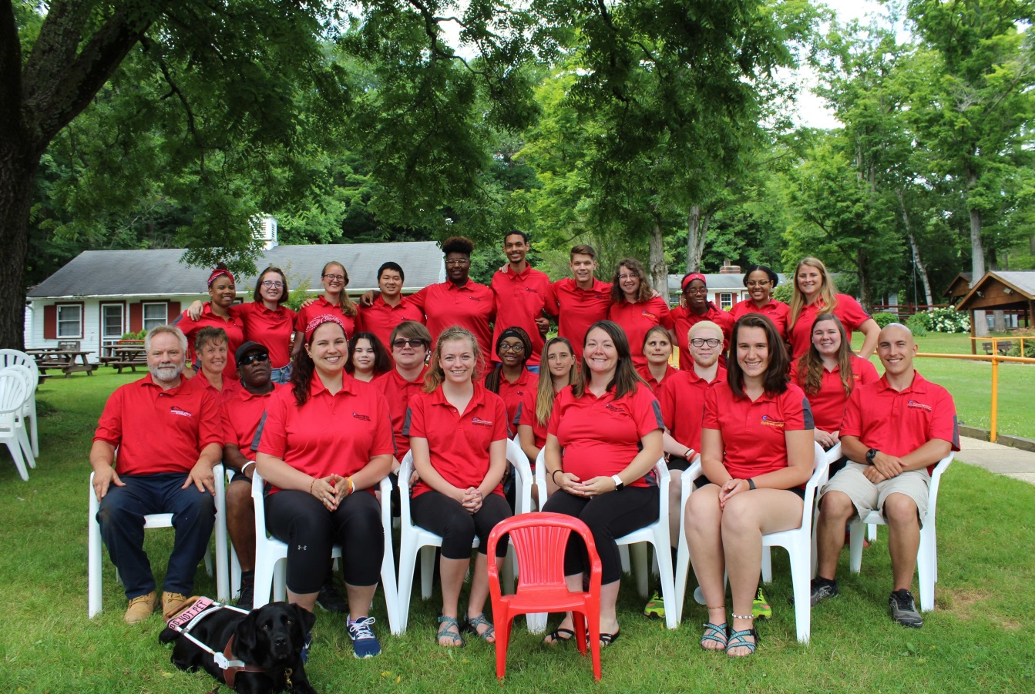

Highbrook Lodge employed 23 seasonal staff members to serve as Cabin Leaders, Program Staff, Lifeguards, Drivers, Camp Nurse, Kitchen Assistants, Maintenance Assistants, and Leadership Team Members. All staff is supported by year round Camp Manager, Lindsay Svarovsky, Therapeutic Recreation Specialist, Mollie Evans, and Camp Ranger, Kevin Pye in addition to seasonal staff member Sarah Whitehouse, Program Coordinator, and Rachel Coury, Camp Coordinator.

Recommendations

The following programmatic recommendations are being made by the Manager of TR/Camp Manager and the Therapeutic Recreation Specialist for summer 2019 based off continued observation and assessment of camp programming from summers 2015-2018.

- This summer, we saw a decrease in the number of kids, tweens and teens attending camp, despite this group benefiting the most from camp programming. It is recommended that this age demographic be a continued focus of camp. Continued efforts to engage with, and market to, this specific age group are recommended. Some travel may be required by the Camp Manager to help spread Camp’s reach.

- Young Adult and Fit and Fabulous Camps have not gained traction with clients as a popular session. These sessions should not be included in next year’s schedule, as the resources used to market and plan for this session would be better devoted to other sessions.

- It is recommended that Bright Futures continue to be marketed as a family camp, to encourage family participation in Camp programming. Bright Futures campers are considered clients who are 7 years of age or younger. It is important to have camp opportunities for young clients, and, clients seem to get the most benefit from camp programming when they participate with support from parents, guardians, or siblings.

- This summer, the Bright Futures Day Trip was offered on the last day of the Bright Futures Weekend. This worked well in promoting interactions among families, and benefitted the campers greatly. This should be considered as a possibility for next year’s schedule.

- To continue increasing the utilization of camp it is recommended that camp be marketed and focused on as Cleveland Sight Center’s premier recreation activity for the summer for clients. As the Therapeutic Recreation department continues to move towards a more streamlined, goal-focused, therapeutic model it would be recommended that clients who can safely benefit from the camp experience be recommended and referred by other departments. Continued education to other departments of the agency is encouraged so proper referrals are made.

- Using the online registration tool was incredibly beneficial this summer, and should continue to be used, as it will be even easier for campers and guardians to use in upcoming summers.

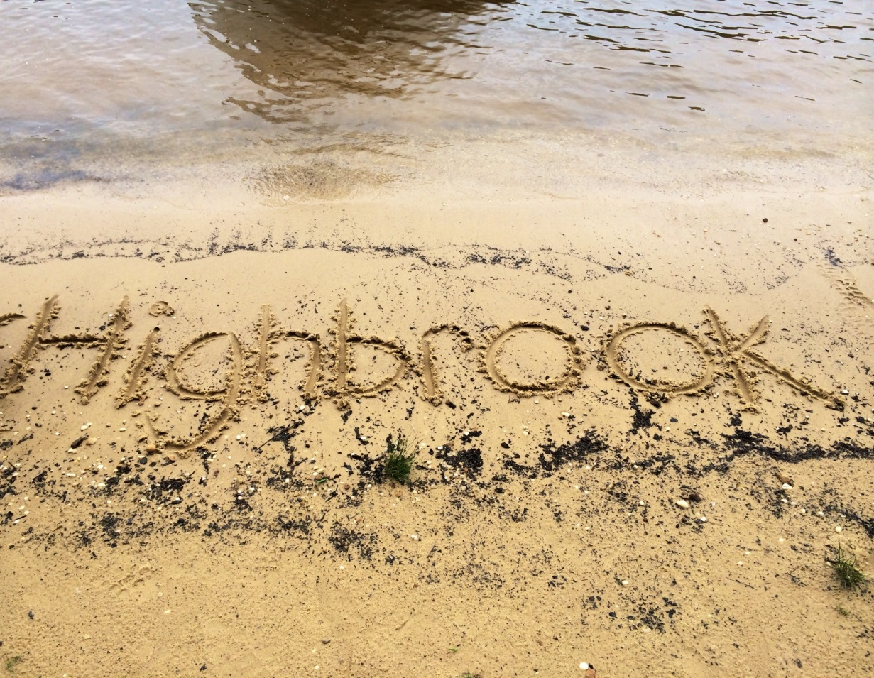

For More Information Contact:
Mollie Evans, TRS 216-791-8118
Cleveland Sight Center- Highbrook Lodge mevans@clevelandsightcenter.org
1909 East 101 Street www.clevelandsightcenter.org/highbrook-lodge
Cleveland, OH 44106

Utilization in this report is based off of 30 beds, due to staff and camper housing availability and our supervision ratios.

