

**Keeping You “In the Know…” 4/19/19**

**Strengthening Partnerships and Educating the Community:**

-[Delta Gamma Cleveland East Alumnae](https://www.facebook.com/DGClevelandEast/?__tn__=K-R&eid=ARBn_D5huvNUS-_0rAdXK8p19FxvRRMqRmrjFDWEpXhUgnjLvd5BA3R6wb08tXmM2MJXP1HfSyzKogCl&fref=mentions&__xts__%5B0%5D=68.ARCRZ3auWY0vQQSA8GLivxf-xnqgfXf4AgrK8dFmnAEBlRpyUdSnSXCse2O5zbDR_sVEQ3p5X60aFQF1FtA2shEOGOxER4qzayzcvVrC8q9w3lfi1rVv9oDs02JLo1dT5Z3xST9PkiqW7atf7a_Yn77hjdn2b6tSAjj2uTC0A53WoQ25u03dH2B5k_37hhtoQwQwU1Os5aO7jCMwnA28Usyi1ti9gsWwTmBG3IbQTEuHL1_euGElAEf-yPaO_v7puttkIYU9BvC_eQwG1LwHlHv_hoWMIaXKNuSCFVDTY7qBCSXUgF7KDLM5nQS8g_2rMT-Ihn-bDvCAk1qxFgiXeH5LAw) hosted “A Night at the Races” to benefit Cleveland Sight Center last weekend. CSC’s Clyde E. Williams, Jr. Auditorium was turned into a horse racing emporium with decorations galore and tons of energy throughout the evening! Attendees enjoyed great food and drink, fantastic camaraderie, many laughs and friendly competition betting on the races. Our sincere thanks and appreciation to those who attended, planned the event, supported through sponsorship and the alumnae of Delta Gamma Cleveland East for their tremendous passion, support and ongoing commitment to Cleveland Sight Center!

-CSC recently received a gift from the Delta Gamma Alumnae – Westshore group to support Recreation services and programs! Thank you, Delta Gamma Alumnae – Westshore!  
  
-CSC recently received a grant from the John P. Murphy Foundation to support the Children & Young Adult Services (CYAS) Summer Youth Work Experience program scheduled for June 9 – July 12.  
  
-Chris Gruber, Jenny Schaeffer and Vince Williams attended a Spring Camp Facilities Tour hosted by the American Camp Association this week. They toured several camps in the area to discuss CSC’s own camp experiences and learn about the different designs used by other camp professionals.  
  
-The Outreach team visited Sumitomo Demag, a company in Strongsville that manufactures a wide range of high-precision, plastic injection molding machines for diverse applications, presenting on vision health and CSC programs and services at the company’s health fair.

-The sisters of Delta Gamma at Case Western Reserve University (CWRU) hosted a “Pancake Night for Sight” at their Delta Gamma house on Thursday, April 18th. Attendees enjoyed pancakes and but also learned how Cleveland Sight Center provides programs and services to individuals who are blind or have low vision. Melissa Mauk represented the agency to engage participants in various activities and answer questions about CSC.

-CSC will be collaborating with various agencies in the planning of the 2019 ADA Day, which will be held during a Wade Oval Wednesday in University Circle on Wednesday, July 17th. More details will be shared as they are announced.  
  
  
**What’s Happening at CSC:**

-Social Recreation introduced a new game at this week’s Game Day on Tuesday…Left, Right, Center. Instead of dice there are brailled cards with a picture of a dye with an L, R, C, or the safe symbol. The group was very enthusiastic throughout the game and one attendee who was not playing the game was very amused with all the laughter and excitement and recorded the action! They can’t wait to play it again next Game Day and even want to take it to Highbrook Lodge for the adult camper session this summer. Others Game Dayers were engaged in a rousing game of UNO with Jenny Schaeffer and Vince Williams.

-The Volunteer Appreciation Dinner will be held at CSC on Thursday, April 25th. The event will be from 5:30 p.m. – 7:30 p.m. and doors will open at 5:00 p.m. Invite or encourage volunteers you work with to attend CSC’s “Snacks and Facts” sessions, where attendees can grab a snack to meet other CSC volunteers and staff, try out low vision tools and complete a task wearing low vision simulators.

Tuesday, April 23rd 11:00 a.m. - 12:00 p.m.

Wednesday, April 24th 11:00 a.m. - 12:00 p.m.

Thursday, April 25th 9:30 a.m. - 10:30 a.m.

-One of CSC’s Employment clients referred by Opportunities for Ohioans with Disabilities (OOD) is currently in her first 90 days at the Tudor Arms Hotel. Deborah Dalton and Melody Dyer are working with the team at the Tudor Arms Hotel to facilitate her initial training and Rosalie Daley has met with the hotel’s general manager to place the client.  
  
-Children & Young Adult Services (CYAS) continues plans for summer programs and spots are filling fast! Programs include the following and for more information, [click here](http://clevelandsightcenter.org/programs-services/school-age-children-3-20-years-old) or contact Sylvia Snyder (x8777).  
 -Bright Futures Summer Day Camp (preschool ages)

June 10 - July 3 (9:00 - 12:00)  
 -ABCs Summer Day Camp (ages 5 - 8)

July 8 - August 1 (9:00 - 12:00)  
-Summer Youth Work Experience program (ages 16 - 22)    
June 9 - July 12 (residential)  
-Career Exploration program (ages 14 - 16)    
July 22 - August 2 (9:00 - 4:00)

-To assist with summer programs and gain valuable experience, CYAS will be hosting eight interns from Ohio State University (4 interns), Shawnee State University (2 interns), Western Michigan University (1 intern) and the University of Southern California (1 intern).

-Save the date: Bright Futures Preschool graduation will be Thursday, May 23rd at 10:00 a.m. in the Clyde E. Williams, Jr. Auditorium at CSC.

-Save the date part two: Winners Club will meet at CSC on Thursday, May 30th and will feature a performance by the Music Group that meets at CSC on the first and third Tuesdays (4:30 p.m. – 6:30 p.m.) of every month. For more information on both Winners Club and Music Group, contact Alicia Howerton (x4587).

**Congratulations, You’re Awesome!**   
  
-Congratulations to the following CSC staff members for winning the Random Acts of Awesome Awards:

-Jim Hlavaty, nominated by Officer Adam Gilmore

-Nicole Kahn, nominated by Steve Sharrock

-Matt Jennings, nominated by Nick Rothermel

-Barbara Piascik, nominated by Stephanie O’Donnell

-Officer David Rios, nominated by Moreed Kamal  
  
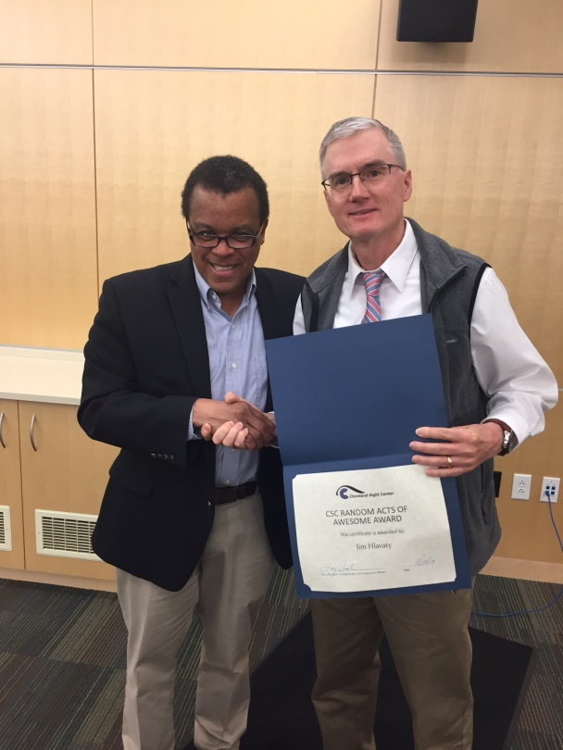  
Larry Benders and Jim Hlavaty

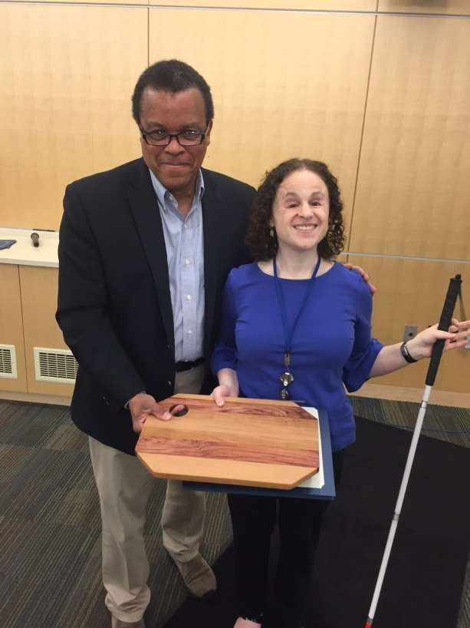

Larry Benders and Nicole Kahn

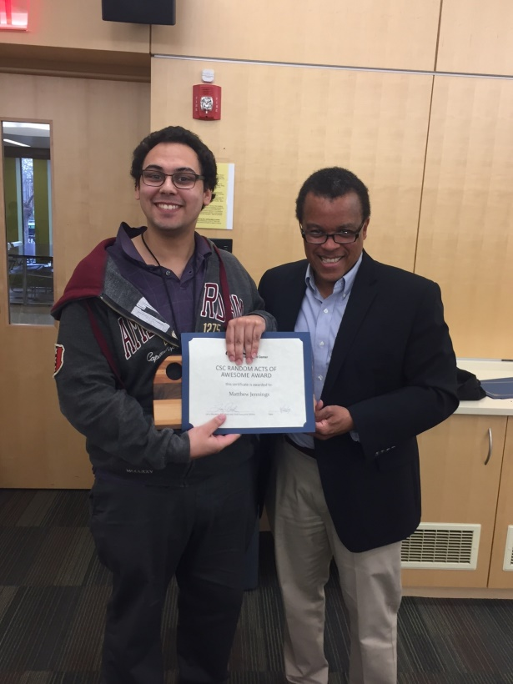  
Matt Jennings and Larry Benders

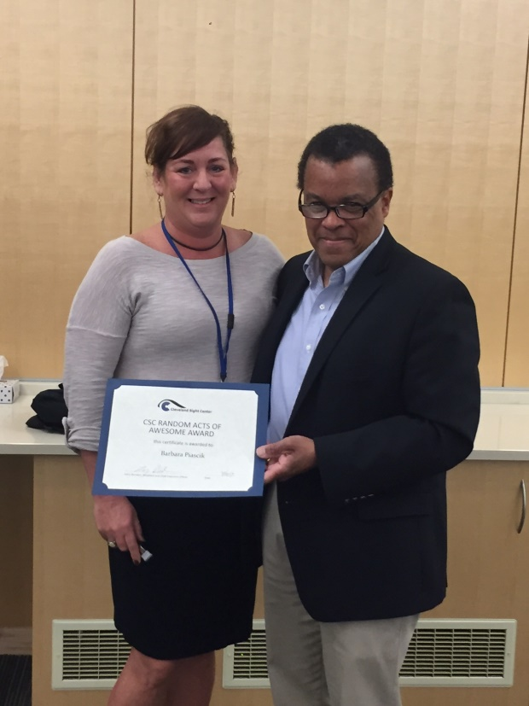

Barbara Piascik and Larry Benders

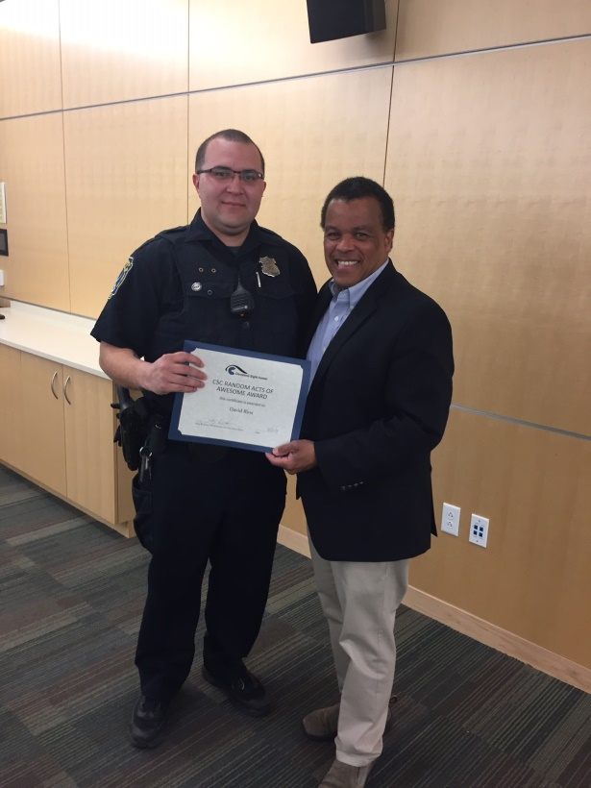

Officer David Rios and Larry Benders

-Congratulations to those nominated for the award for their awesome acts:   
-Tony Becker, nominated by Monica Owen

-Stephanie O’Donnell, Jim Hlavaty and the Security Officers nominated

by Rosalie Daley

-Nicole Kahn and Jennifer Dean, nominated by Tina Pringpuangkeo

-Wilbert Turner, nominated by Jassen Tawil

-David Magyar and Jassen Tawil, nominated by Ali Thomas  
  
  
**Items of Note:**   
  
-A study suggests up to 90% of school leavers in major Asian cities are suffering from myopia (short-sightedness).Researchers say the "extraordinary rise" in the problem is being caused by students working very hard in school and missing out on outdoor light. The scientists told the Lancet that up to one in five of these students could experience severe visual impairment and even blindness. To read the full article from the BBC, [click here](https://www.bbc.com/news/health-17942181).

-Cuyahoga Valley Church hosts an annual Egg Grab including a sensory friendly/adaptive Egg Hunt that takes place at the same time. For individuals who need assistance locating eggs, beeping eggs will be available. Lots of non-candy treats for this with allergies and eggs placed at various levels for mobility needs. The event is Saturday, April 20th at 6:15 p.m. at the Cuyahoga Valley Church, 5055 E. Wallings Road in Broadview Heights. For more information, [click here](https://www.facebook.com/events/785813941803161/).  
  
-Services for Independent Living (SIL) will host the May 21st “Celebrating Inclusion: Beyond the Basics” conference.  As individuals with disabilities, family members and professionals, people often get so caught up in access to the basics: healthcare, housing, employment and more that they forget about the things that feed the soul and make life meaningful. It is with this thought in mind, this conference has been developed. Attendees are welcome to join the conference for a full day of enlightenment, fun and skill building as they learn from professionals and individuals directly impacted by disability. Continuing education credits will be offered and panels include the following topics:

Access to Travel

Access to Arts, Leisure & Recreational Opportunities

Assistive Technology

Civic Engagement

Parenting & Personal Relationships

Real-Life Stories: “You Are Not Going to Believe This!”  
  
The conference will be Tuesday, May 21, 2019 9:00 a.m. to 5:00 p.m. (Registration at 8:00 a.m.) at the Holiday Inn Rockside, 6001 Rockside Road, Independence, Ohio, 44131. For more information or to register, [click here](https://www.eventbrite.com/e/celebrating-inclusion-beyond-the-basics-tickets-59663411871) or contact Laura Gold at lgold@sil-oh.org or at 216-815-0015

-Stop by the Beck Center for the Arts in Lakewood between now and July 1st to check out friend of CSC’s Owen McCafferty’s “Owen’s Gallery of Visual Art” on display in the music & dance building behind the theater. The gallery features acrylic paintings, textural artwork and digital artwork. The exhibit is open Monday – Friday from 9:00 a.m. – 6:00 p.m. and located at 17801 Detroit Avenue, Lakewood OH 44107.