Establishing Your Legacy with Cleveland Sight Center
Sample Language for Bequests

Bequests

Naming Cleveland Sight Center as a beneficiary of a will is one of the most meaningful ways to make a gift. You may leave a bequest as a specific sum of money, a percentage of your estate, or a gift of the remainder of your estate after distribution to loved ones. If your will is already written, you can add a codicil to update your intent.

We hope you inform us of your bequest so we may recognize your philanthropy.

Sample Language

“I give to Cleveland Sight Center, in Cleveland, Ohio … [possible choices]
- a cash bequest of ($______);
- a percentage (____%) of my estate;
- the residue of my estate.
I request that this bequest be used for the following purpose: (program/designation, if applicable.) I designate that no federal estate tax or state death taxes be allocated to or paid from such bequest.”

Contingent Gift Language

“If (insert name) is not living at the time of my demise, I give to Cleveland Sight Center, in Cleveland Ohio, the sum of $_______ (or all or a percentage of the residue of my estate to be used for its (general support or for support of a specific program).”

To speak with a member of our team about establishing your legacy with Cleveland Sight Center, please contact the Development Office at 216-658-4565 or hmarblestone@clevelandsightcenter.org.

This document is prepared for general information.
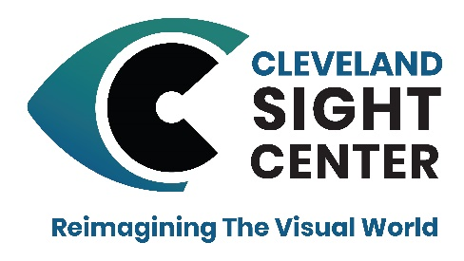
Please consult your professional advisor for counsel.
Legal Name: Cleveland Sight Center OR Cleveland Society for the Blind
Federal ID: 34-0714652
Address: 1909 E. 101st St. Cleveland, OH 44106

